* Conveyance Process (Monthly Activity from 11th to 25th)
  + **Conveyance Portal ID creation**
  + Step 1:- Master – Employee
    - Select New and fill employee details
  + Step 2:- Master- login
    - Employees Login ID would be firstname.lastname
  + Step 3:- Admin- Assign Role
    - Assign relevant role to the employee
  + **Conveyance Portal** (https://cloverinfotech.co.in:8082/PORTAL)
  + Admin Tab
  + Conveyance Recommendation.
  + Select Month / Year and pending filtered (have to process latest 2 months).
  + Click on details for processing for each employee.
  + Check conveyance details as per policy.
  + If not as per policy, then drop a mail to employee and their managers in loop.
  + Only M4 & above managers are entitled to travel claim conveyance on portal.
  + All other employees can claim only Night Shift allowances from conveyance portal.
  + Have to validate & review.
  + Process the actual night shifts conveyance.
  + Have to put remarks for deviation in conveyance sheet.

(more than 10 night shifts or additional conveyance claimed).

* + Send deviation report to the manager’s looping HOD & Finance approval on deviation.
  + All managers have to attached travel supporting bills.
  + Before processing conveyance, have to send mail to consultants for rectification of errors as it impacts conveyance of the employees
* **Night Shift Allowance Policy**:
* Those employees who work more than 2 hours between 11pm – 6am can claim Night Shift Allowance Rs. 250/- per night. This is to a maximum of Rs. 2,500-/ per month. This amount includes (conveyance, dinner).
* If Employees is doing more than 10 night shifts, then respective manager has to give approval on deviation with relevant reason.
* In case of those Employees who attend the client during night for Severity I activity, will be paid Conveyance at actuals. Employees are expected to take the most reasonable mode of transport. They are also allowed Dinner reimbursement to a maximum of Rs. 100/-. The same is allowed after 10pm.
* Employees based in office who are in Grade M4 and above from Delivery, Sales and other department, who travel to client places will be entitled to actual conveyance as approved by their Supervising Manager.
* Employees who are in Grade M4 and above who use their own vehicle for official purpose would be reimbursed at the rate of Rs. 4 per kilometer for two wheelers.
* Employees who are in Grade M5 who use their own car would be reimbursed at the rate of Rs.8 per kilometer (in case of Petrol car) and Rs. 6 (in case of CNG or Diesel) for four wheelers.
* All local conveyance should be claimed on Clover Conveyance Portal and would be on actuals with accurate supporting and adequate details.
* All taxi fare claims are admissible only with submission of adequate supporting bills.
* All auto fare claims should mention the distance covered in kilometer.
* All claims should be made on a monthly basis.
* Submit photocopy of the pass/railway ticket in case of claims of 1st Class rail fare, in the absence of the same, reimbursement will be done as per the rate of 2ndclass pass/ticket.
* All claims for conveyance shall be submitted, latest by 10th of every month through the Clover Conveyance Portal.
* All claims shall be checked and approved in the portal by Heads of Department and submitted along with supporting documents to Accounts Department.
* Respective supervising Manager to take due care while approving and if there are deviations the same should be informed to the Finance team for approval of claims.
* At all times the employee shall take due care to keep the conveyance cost to minimal.
* All employees should ensure that their claims are in line with above guidelines.
* The Finance team has the right to reject/hold any claim which is not in line with the above guidelines.
* All claims will have to be submitted by the employee by the 10th of the following month. The same will be processed and forwarded to accounts for payment before 25th of the month.
* The reimbursement will be credited into the accounts of employees latest by 10th of next month of submission of such claim.
* Employee can claim maximum 2 latest month conveyance together. if it is more than 2 months then earlier month conveyance will be lapse.
* While applying for night shift please fill all your night shift claim in night shift claim column only.
* If employee is doing night shift that time employee should enter his attendance twice for 2 diff. days for eg. On 23.04.2017 if employee working from 11.00 pm to 7.00 am then he should have his 2 different attendance on portal i.e. 23.04.2017 in time would be 23.00 pm & out time would be 23.59 pm & again on 24.04.2017 in time would be 00.01 & out time would be 7.00 am. Here employee can claim his night shift allowances against his second entry.
* If we received mail from employee regarding his conveyance reimbursement.
* Will check whether his conveyance for concern month is approved or not.
* If approved, then see the month in which we processed same to finance.
* If not approved, then we check updated date in recommendation.
* **Exceptional Approval**

|  |  |
| --- | --- |
| **Clients** | **Particulars** |
| General Mills | 6000 Rs. Monthly per person |
| Edelweiss | 15 day night shifts have to pay for 1 consultant |
| PMCB | 15-day night shifts have to pay for 1 consultant  **NOC** (Suryakant, Vikas, Manoj) |
| SBI - Batch Support  (App Support Team) | 15 days night shifts have to pay for 1 consultant |
| CITI | All travel expenses should process |

**Outstation Travel Allowance:**

* + Every consultant who are travelling outstation for any official purpose should claim their outstation expenses in travel sheet format.
  + Before travelling outstation, Consultant need to take prior approval from your respective manager in below mentioned format. (below format need to mention in the body of mail not in attachment.)
    - Client Name:
    - Date of Travel:
    - Reason for Travel:
    - From & To Location:
  + Travel sheet should be send along with approval mail from reporting manager for the same.
  + We need original tickets and bills (should be along with GST number) for processing of travelling. (Need to ask courier tickets at Andheri office if consultant is at outstation).
  + In any case we have not received consultants original ticket or bills then we would not be able to process that amount according to travel policy from consultant’s travel claim.
  + We are unable to process consultant’s travel expenses which is more than 2months old.
  + **Outstation Travel Allowance:**
  + Employees travelling within India on official duty are eligible for following Travel benefits:

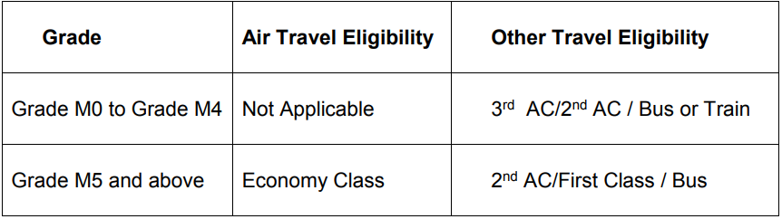

* + Employees in the Grade M5 and above using their own vehicle (Car) for travel to places which is less than 6 hours would be reimbursed at the rate of Rs.8 per kilometer (Petrol vehicle) and Rs. 6 per kilometer in case of (CNG and Diesel vehicle).
  + Such travel needs to have prior approval. Minimum number of employees travelling should be 3. In case of travelling alone only employees of Grade M8 and above are eligible for reimbursement
  + Grade wise eligibility would be as under:

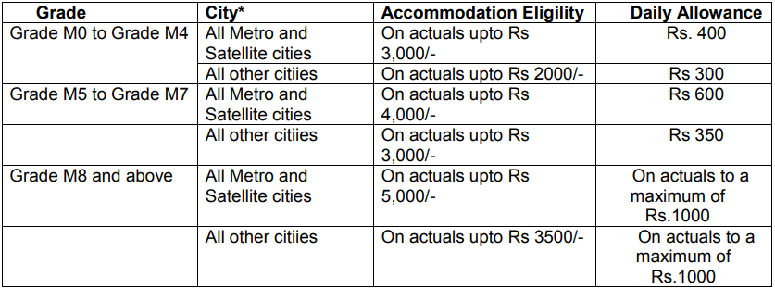

* + Applicability of DA basis of number of hours:



* + Employees are required to use Guesthouse wherever available. Avail of the Corporate hotel tie-ups, in case of both these are not available, employees can book their own accommodation and the above mentioned rates are applicable in such cases. The employees are required to submit the original bills for all such claims.
  + In case an employee making own accommodation arrangement with Family or Friends, will be eligible for reimbursement @ Rs.500 per day apart from the above mentioned DA. However, in instances where the travelling employee prefers to make own stay arrangements, even when Guest House or Company provided accommodation is available, no separate allowance or reimbursement in lieu thereof, can be claimed. In such cases, only the daily allowance can be claimed as per defined eligibility for the Grade.
  + Daily allowance includes expenses incurred towards Tea/Coffee, food including Lunch, Dinner and Communication expenses.
  + All employees need to plan their travel and request for travel arrangements with necessary approvals to the Administration Department, well in advance to avail of best deals. Air travel should be planned minimum one month in advance.
  + In case of Hotel accommodation, employees are expected to settle the bills directly and claim the amount, unless there is a Company tie-up in place whereby the bills will be settled directly by the Company at a later date.
  + Proximity to the office or meeting venue will be the key criteria in selection of Hotels which will also save on commuting time within the city and conveyance costs.

**Travel Advance**:

* + In case of long stay, the employee can avail of travel advance not exceeding Rs. 5,000/- with prior approval of his supervising manager.
  + Any such amount received by the employee should be settled on priority basis within 7 working days on return. In case this advance is not settled as per these timelines, the same would be recovered, in total, from the employees next months’ salary.

**Travel Bookings/Cancellations and Extensions**:

* + In case of any change in the travel plans of the employees resulting in cancellation of the trip, the employee is expected to inform the administration team and also to Department Head with reasons for change or cancellation about the same immediately through mail/verbally with a copy marked to the concerned Administration SPOC so that he/she can cancel the tickets.
  + In case of last minute changes, the employee may cancel the Travel request on the next day. However, the Administration SPOC must be informed verbally about the cancellation. It is very important to avoid “No Show” charges.
  + Delay on part of the employee to inform the Administration SPOC about trip cancellations resulting in “No Show” Charge will be recovered from the employee from the next month’s salary.
  + In case an employee needs to extend or change the travel dates, he/she is required to intimate the Administration SPOC at the earliest given opportunity.
  + Where travel is required at customer’s request and which shall be reimbursed by the customer, prior written confirmation of the customer is to be obtained, or else the company will not reimburse the same. Post travel, employee shall submit all necessary supporting documents and customer’s approval within 7 days of his travel.

**General Guidelines:**

* + All travel plans, arrangements and expenses need to be approved in advance.
  + All such domestic travel needs to be planned well in advance with at least 1-week notification to all stakeholders for optimization of costs as well as resources. In case of Air Travel minimum, 15 days prior planning is required and preferably 1 month.
  + All travel arrangements need to be routed through Administration SPOC for Hotel, Ticket and Guest House booking.
  + In case the arrangements made during such visits, include food, accommodation or local travel arrangements being made by the organization or client, no expenses towards the same can be claimed by the employee.
  + All travel related expenses need to be settled within 1 week of return back to base location.
  + All hotel bills must have GST number mentioned. Bills without GST number will not be approved or reimbursed.
  + Reimbursements towards alcohol, cigarettes and personal expenses are not permissible